Step 1:

---------------------- Pre-request software Installation updates .

[ec2-user@ip-172-31-88-127 ~]$ **minikube version**

minikube version: v1.6.2

commit: 54f28ac5d3a815d1196cd5d57d707439ee4bb392

[ec2-user@ip-172-31-88-127 ~]$ **kubectl get nodes**

NAME STATUS ROLES AGE VERSION

minikube Ready master 13m v1.17.0

[ec2-user@ip-172-31-88-127 ~]$ **kubectl get pod --all-namespaces**

NAMESPACE NAME READY STATUS RESTARTS AGE

kube-system coredns-6955765f44-f28qg 1/1 Running 0 13m

kube-system coredns-6955765f44-kd76n 1/1 Running 0 13m

kube-system etcd-minikube 1/1 Running 0 13m

kube-system kube-addon-manager-minikube 1/1 Running 0 13m

kube-system kube-apiserver-minikube 1/1 Running 0 13m

kube-system kube-controller-manager-minikube 1/1 Running 0 13m

kube-system kube-proxy-h56pz 1/1 Running 0 13m

kube-system kube-scheduler-minikube 1/1 Running 0 13m

kube-system storage-provisioner 1/1 Running 0 13m

[ec2-user@ip-172-31-88-127 ~]$ **docker version**

Client:

Version: 18.09.9-ce

API version: 1.39

Go version: go1.10.3

Git commit: 039a7df

Built: Fri Nov 1 19:26:49 2019

OS/Arch: linux/amd64

Experimental: false

Server:

Engine:

Version: 18.09.9-ce

API version: 1.39 (minimum version 1.12)

Go version: go1.10.3

Git commit: 039a7df

Built: Fri Nov 1 19:28:24 2019

OS/Arch: linux/amd64

Experimental: false

[ec2-user@ip-172-31-88-127 ~]$ **java -version**

java version "1.8.0_131"

Java(TM) SE Runtime Environment (build 1.8.0_131-b11)

Java HotSpot(TM) 64-Bit Server VM (build 25.131-b11, mixed mode)

[ec2-user@ip-172-31-88-127 ~]$ **git version**

git version 2.23.1

[ec2-user@ip-172-31-88-127 ~]$ cd /var/lib/jenkins

[ec2-user@ip-172-31-88-127 jenkins]$ pwd

/var/lib/jenkins

[ec2-user@ip-172-31-88-127 jenkins]$

[ec2-user@ip-172-31-88-127 jenkins]$ sudo systemctl status jenkins

● jenkins.service - LSB: Jenkins Automation Server

Loaded: loaded (/etc/rc.d/init.d/jenkins; bad; vendor preset: disabled)

Active: **active (running)** since Mon 2020-02-03 07:29:56 UTC; 9s ago

Docs: man:systemd-sysv-generator(8)

Process: 31120 ExecStart=/etc/rc.d/init.d/jenkins start (code=exited, status=0/SUCCESS)

Tasks: 41

Memory: 463.1M

CGroup: /system.slice/jenkins.service

└─31172 /etc/alternatives/java -Dcom.sun.akuma.Daemon=daemonized -Djava.awt.headless=true -DJENKINS_HOME=/var/lib/jenkin...

Feb 03 07:29:55 ip-172-31-88-127.ec2.internal systemd[1]: Starting LSB: Jenkins Automation Server...

Feb 03 07:29:55 ip-172-31-88-127.ec2.internal runuser[31154]: pam_unix(runuser:session): session opened for user jenkins by (uid=0)

Feb 03 07:29:56 ip-172-31-88-127.ec2.internal runuser[31154]: pam_unix(runuser:session): session closed for user jenkins

Feb 03 07:29:56 ip-172-31-88-127.ec2.internal jenkins[31120]: Starting Jenkins [ OK ]

Feb 03 07:29:56 ip-172-31-88-127.ec2.internal systemd[1]: Started LSB: Jenkins Automation Serve

[ec2-user@ip-172-31-88-127 pipeline_project_test]$ sudo service sonar status

**SonarQube is running (32422).**

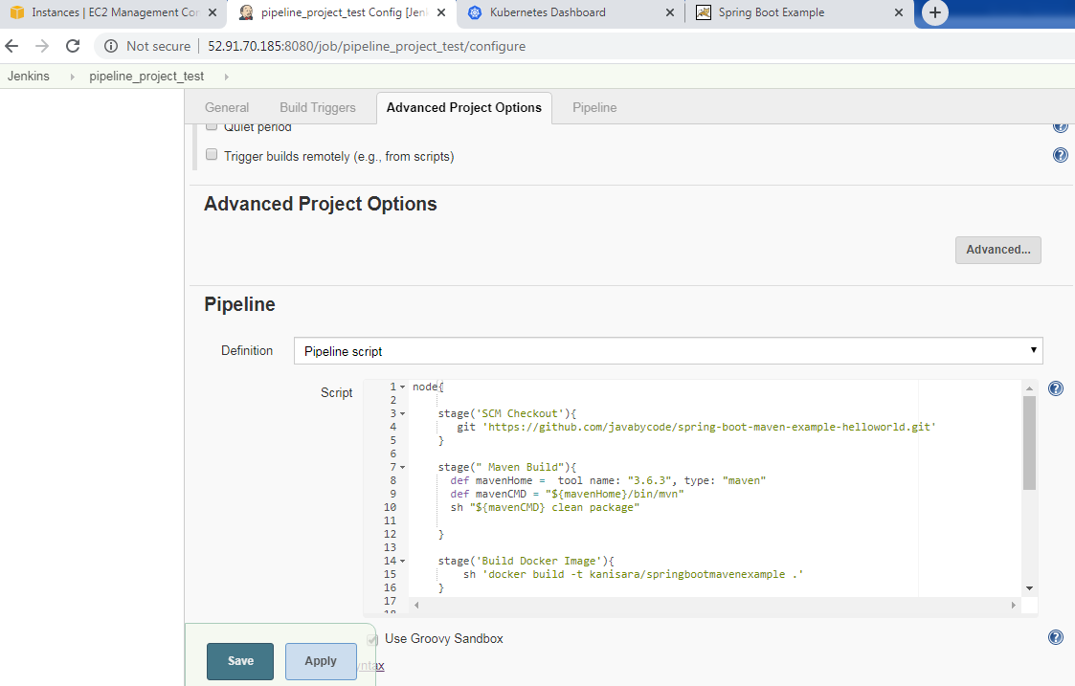

Finally application was able access now. Please see the screenshot.

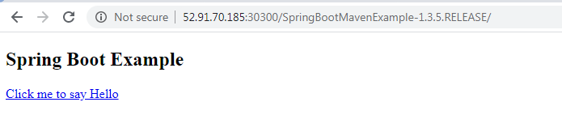

**Kubernetes console management**

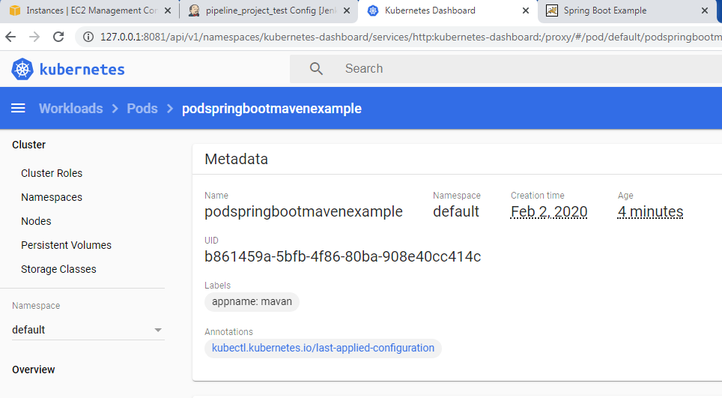 **Jenkins Pipeline scripts**

**node{**

**stage('SCM Checkout'){**

**git 'https://github.com/kanisara/spring-boot-maven-example-helloworld.git'**

**}**

**stage(" Maven Build"){**

**def mavenHome = tool name: "3.6.3", type: "maven"**

**def mavenCMD = "${mavenHome}/bin/mvn"**

**sh "${mavenCMD} clean package"**

**}**

**stage(" Quality control check"){**

**def mavenHome = tool name: "3.6.3", type: "maven"**

**def mavenCMD = "${mavenHome}/bin/mvn"**

**sh "${mavenCMD} sonar:sonar"**

**}**

**stage(" deploy Artifact into remote repo"){**

**def mavenHome = tool name: "3.6.3", type: "maven"**

**def mavenCMD = "${mavenHome}/bin/mvn"**

**sh "${mavenCMD} deploy"**

**}**

**stage('Build Docker Image'){**

**sh 'docker build -t kanisara/springbootmavenexample .'**

**}**

**stage('Push Docker Image'){**

**withCredentials([string(credentialsId: 'Docker_Hub_Pwd', variable: 'Docker_Hub_Pwd')]) {**

**sh "docker login -u kanisara -p ${Docker_Hub_Pwd}"**

**}**

**sh 'docker push kanisara/springbootmavenexample'**

**}**

**stage("Deploy To Kuberates Cluster"){**

**sh 'kubectl apply -f springbootmavenexample.yml'**

**}**

**}**

************ Docker file *****

**FROM tomcat:8.0.20-jre8**

**COPY target/SpringBootMavenExample-1.3.5.RELEASE.war /usr/local/tomcat/webapps/SpringBootMavenExample-1.3.5.RELEASE.war**

********************** springbootmavenexample.yml

apiVersion: v1

kind: Pod

metadata:

name: podspringbootmavenexample

labels:

appname: mavan

spec:

containers:

- name: springbootmavenexample-container

image: kanisara/springbootmavenexample

ports:

- containerPort: 8080

...

---

apiVersion: v1

kind: Service

metadata:

name: httpdnodeportservice

spec:

selector:

appname: mavan #-- > Label of pod

type: NodePort

ports:

- port: 80 #--> Service Port

targetPort: 8080 #--> Container Port

nodePort: 30300